Oleksandr Romanchenko

83459

Decision tree

First, loading the data and checking its structure: whether all columns are numeric

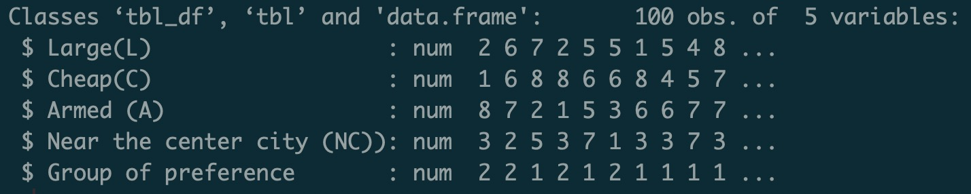

Renaming columns and checking how many observations were classified to each group

Dividing data on training and validation datasets

Building first tree model



Getting the plot with tree

Now making prediction for validation dataset

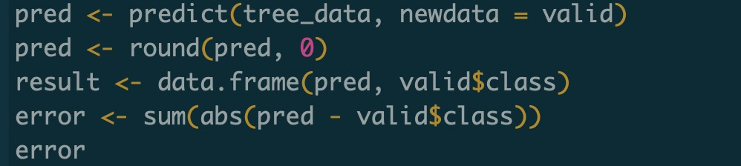

As we can see – model predicts 6 cases incorrectly.

Now let’s try **rpart** model with the same data:

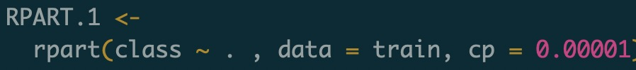

Setting up complexity parameter to a very small number I can increase model complexity.

Let’s have a look at the plot which shows how the error decreases when **cp** increases

Draw a plot with tree

Plotting fancy version of tree diagram using **rattle** package

Plot shows that:

* at the 1st split condition (cost>=3.5) was fulfilled for 47 cases and wasn’t for 23. These 23 were all classified to class 2 (because average number is 2 – meaning that all numbers there = 2)
* at the 2nd split condition (nearcity >=2.5) was fulfilled for 37 cases and wasn’t for 10. These 10 were all classified to class 2
* at the 3rd split condition (fited >= 3.5) was fulfilled for 29 cases and wasn’t for 8.

These 29 were all classified to class 1. For 8 cases leaf shows average 1.4 which tells that some of them were classified to class 1 and some to class 2

Now, let’s check prediction with this model and compute the error

The model predicts all cases in validation dataset correctly

**Conclusion**

During the experiment I’ve tried 2 models: **tree** and **rpart**. Tree model did 6 mistakes on validation data, rpart – 0 mistakes. In previous homework I’ve used neural network which did 1 mistake so I can conclude that rpart model performed even a bit better than network.